/\* Ashok JRP II lab 9.20.19\*/

What to Submit:

Mandatory Videos: Copy and paste the link to your video(s) as part of your homework.

1. SQL BI Interview Questions: Tell me about your SQL Experience

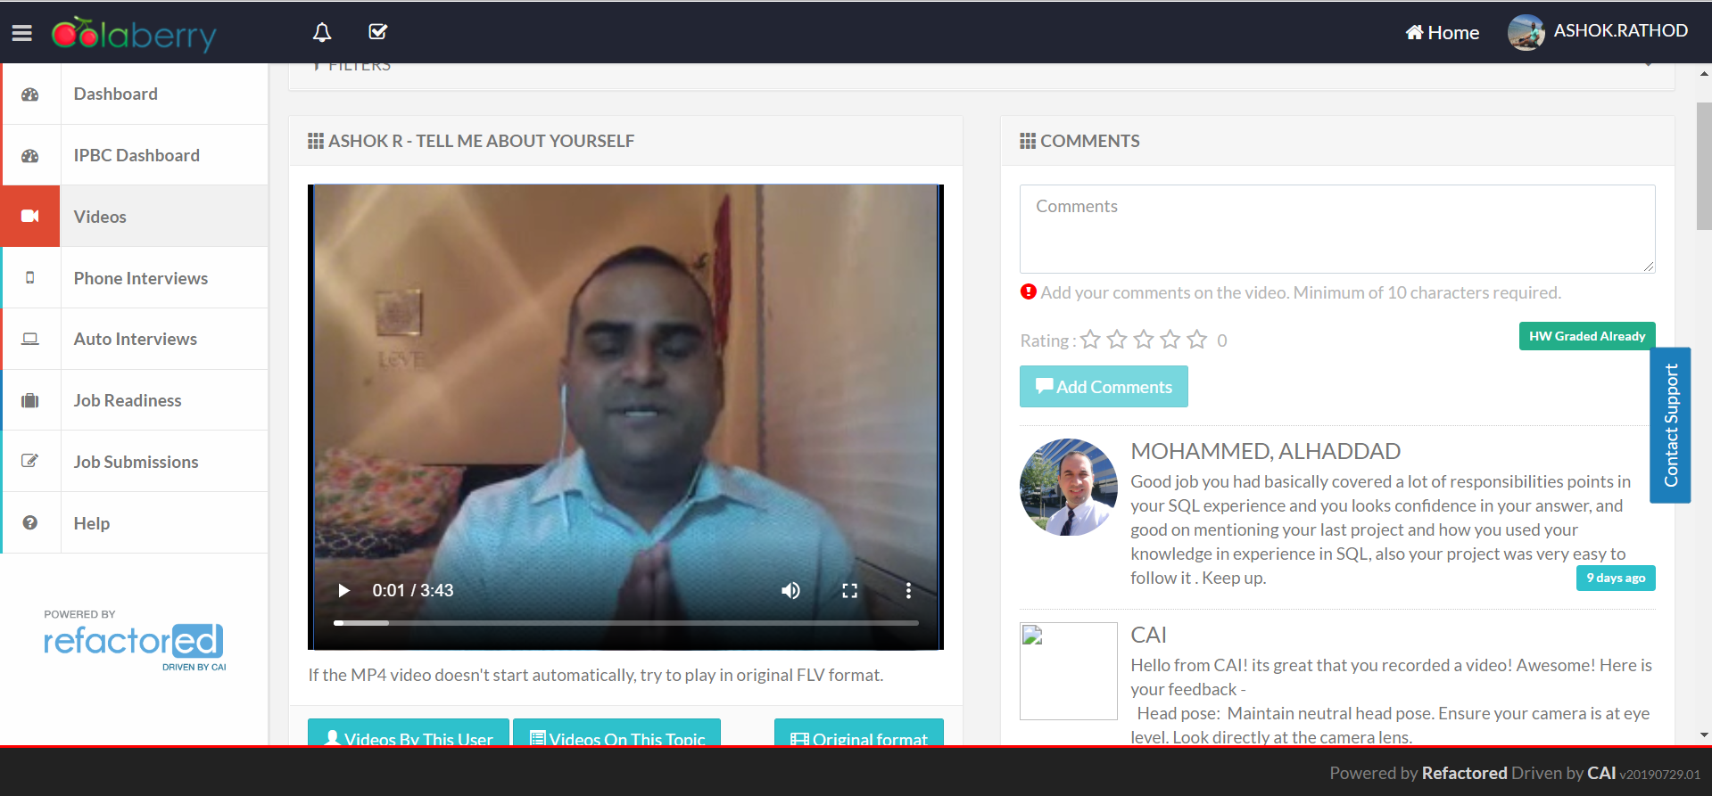

1. SQL BI Interview Questions: Tell me about your SSIS Experience

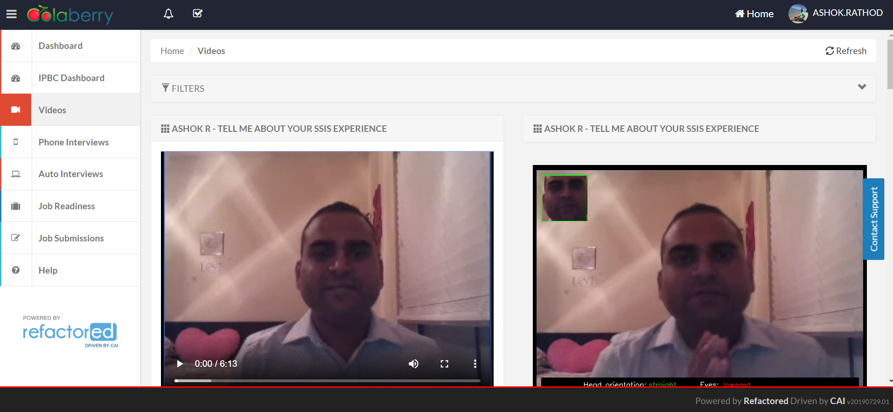

1. SQL BI Interview Questions: Tell me about your SSRS Experience

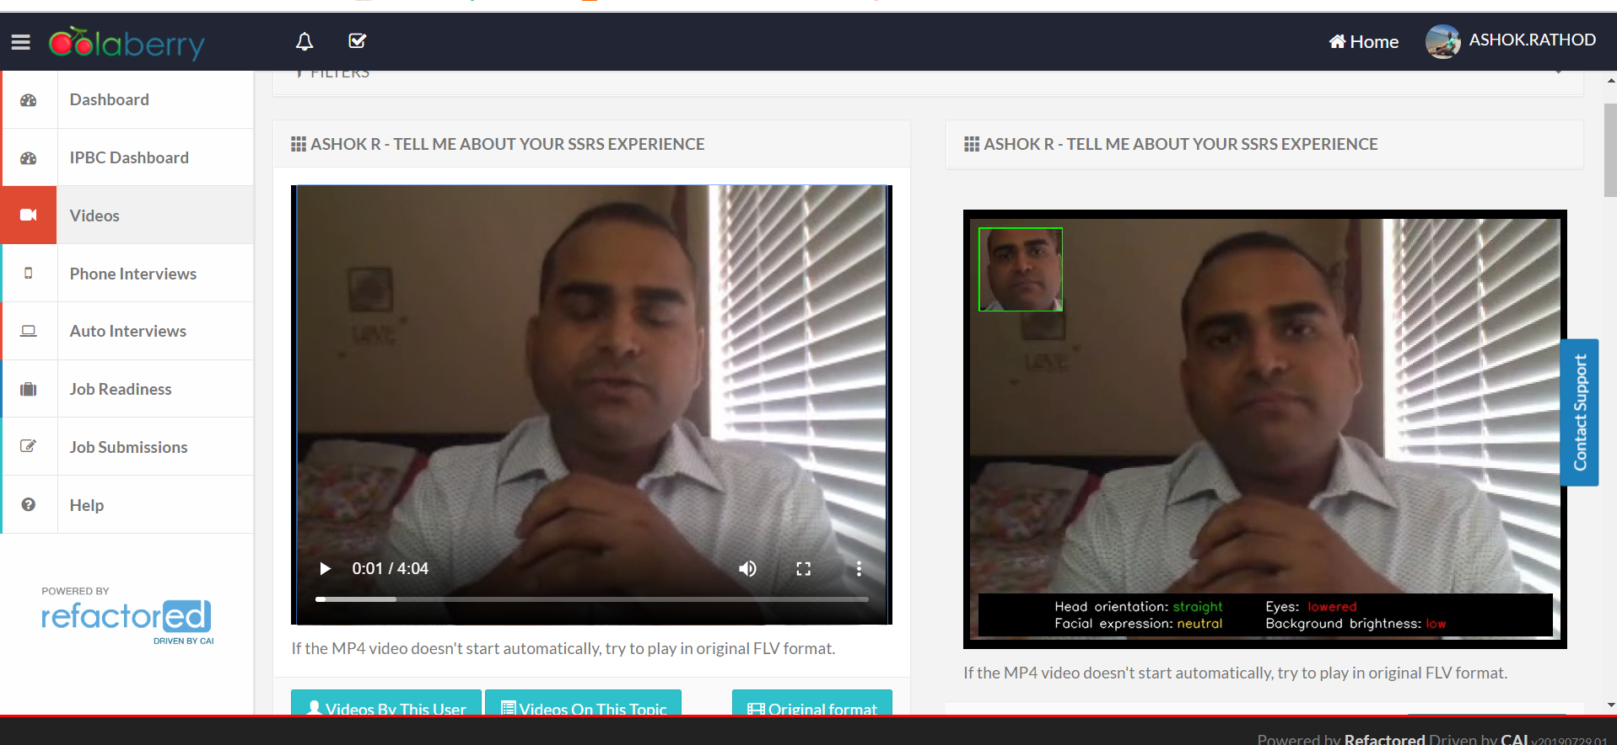

1. SQL BI Interview Questions: Tell me about your SSAS Experience

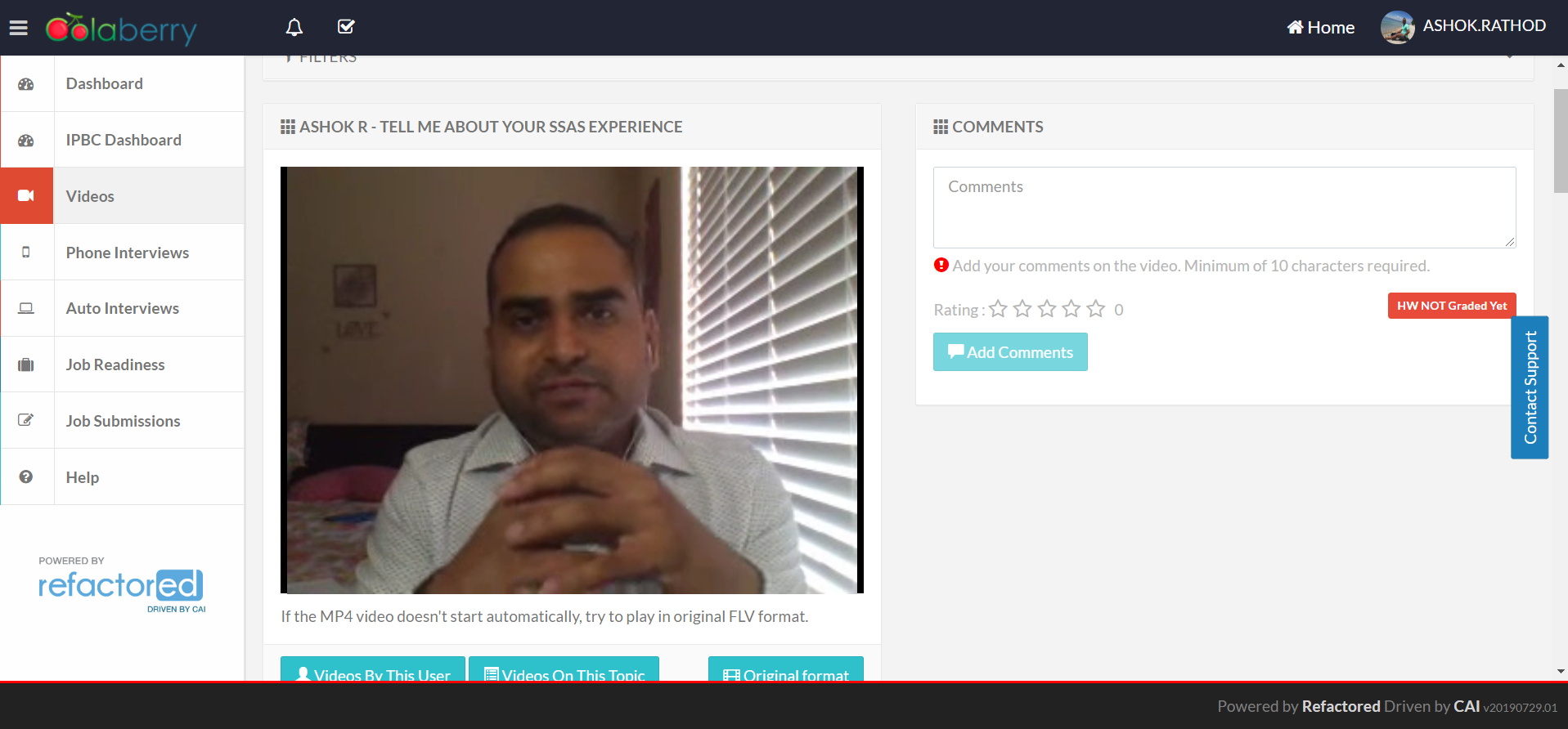

2. Comments: Watch, Comment &amp; take screenshots of your comments from 3 other videos on

the same topic (per question). Comments must be 20+ characters. Leave comments based

on presentation, delivery and/or technical details. Your critiques will help you be more

conscious of your own videos.

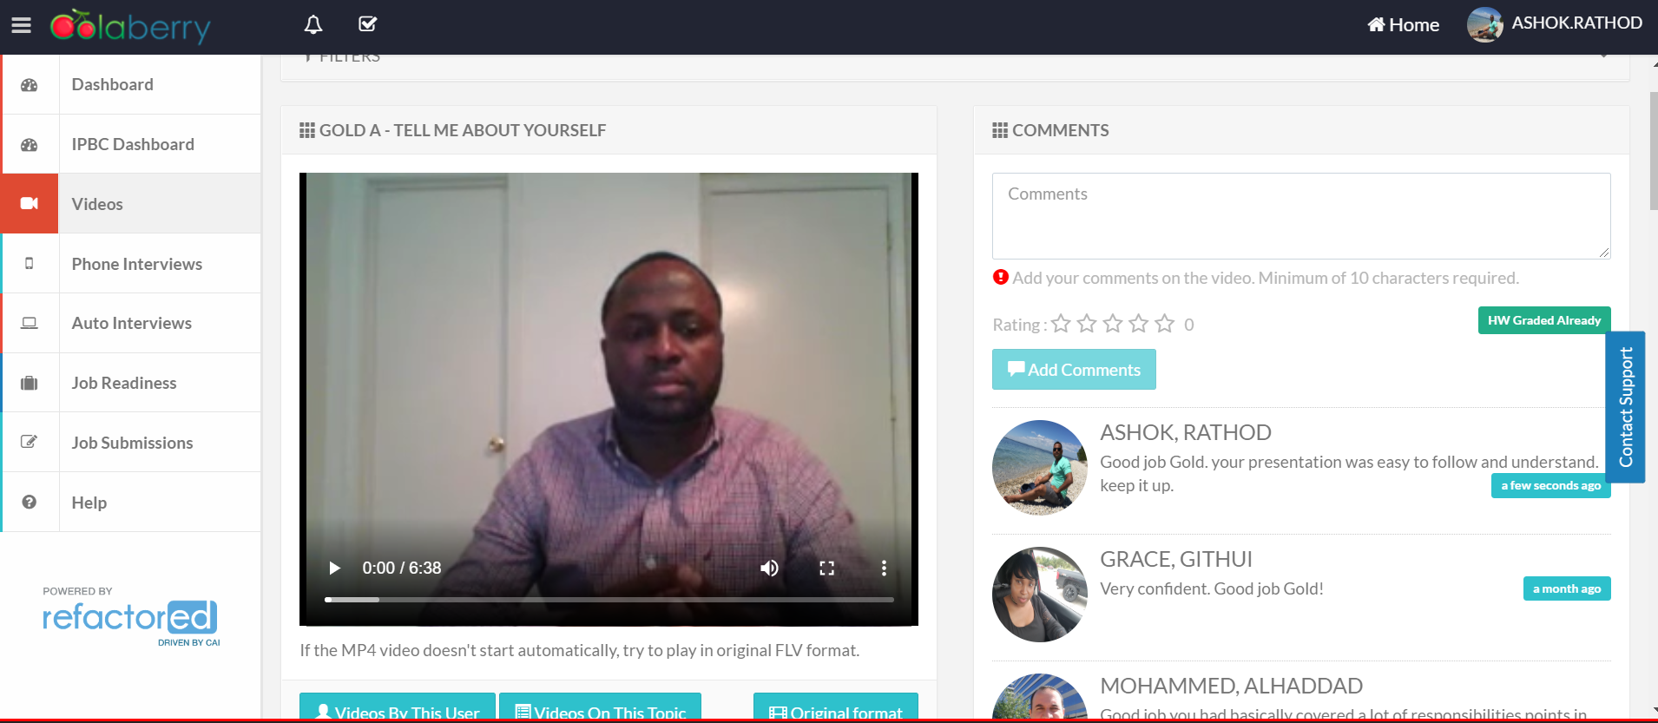 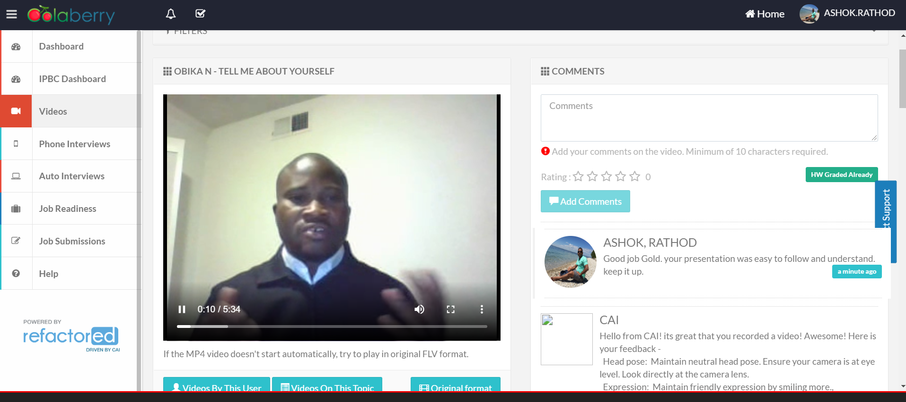

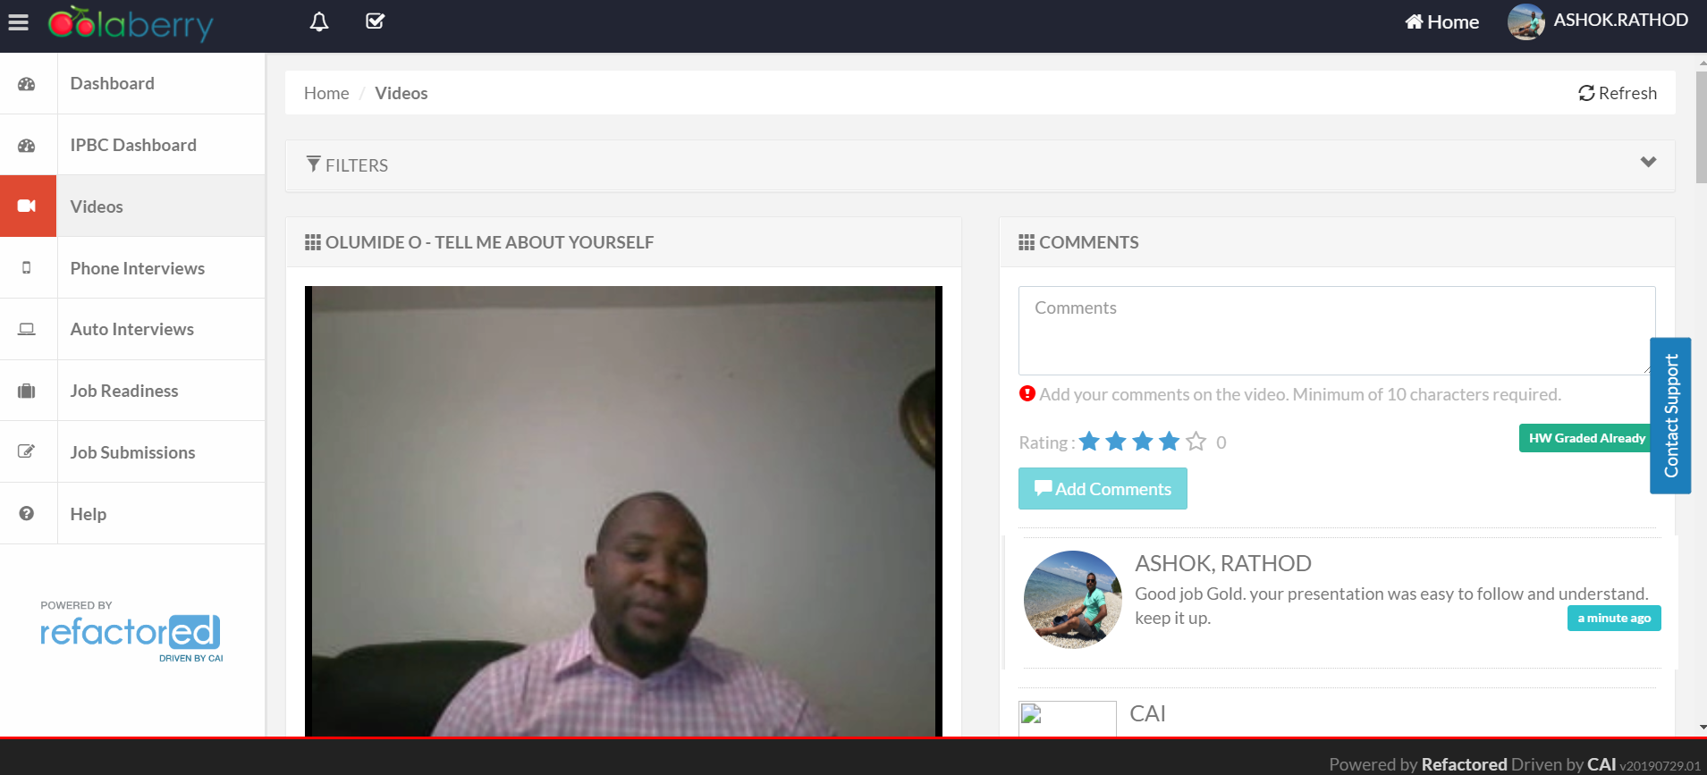

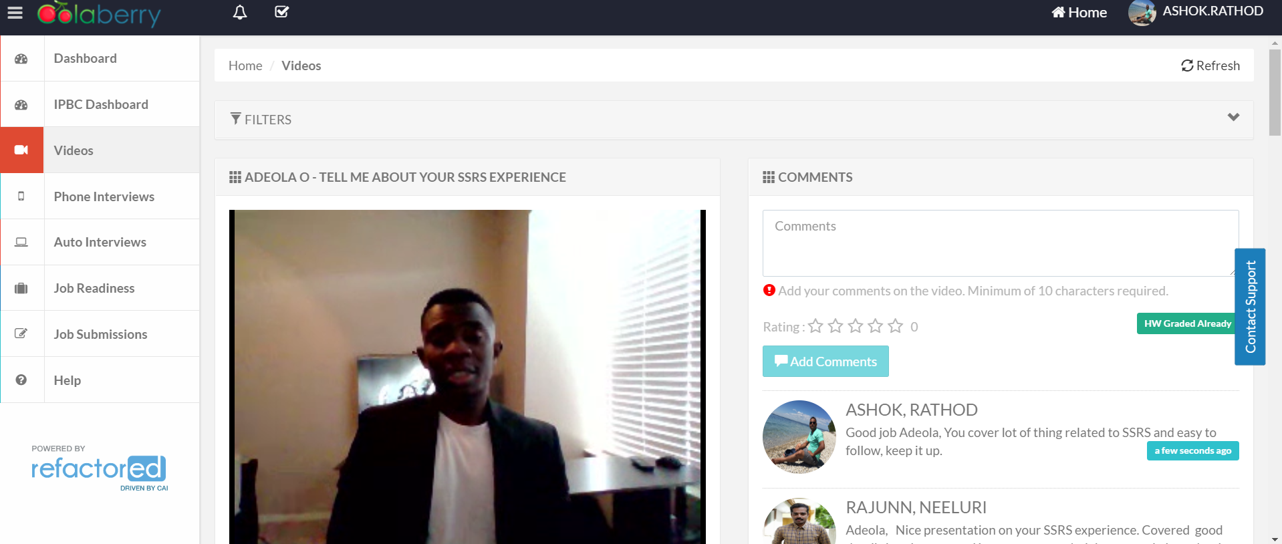

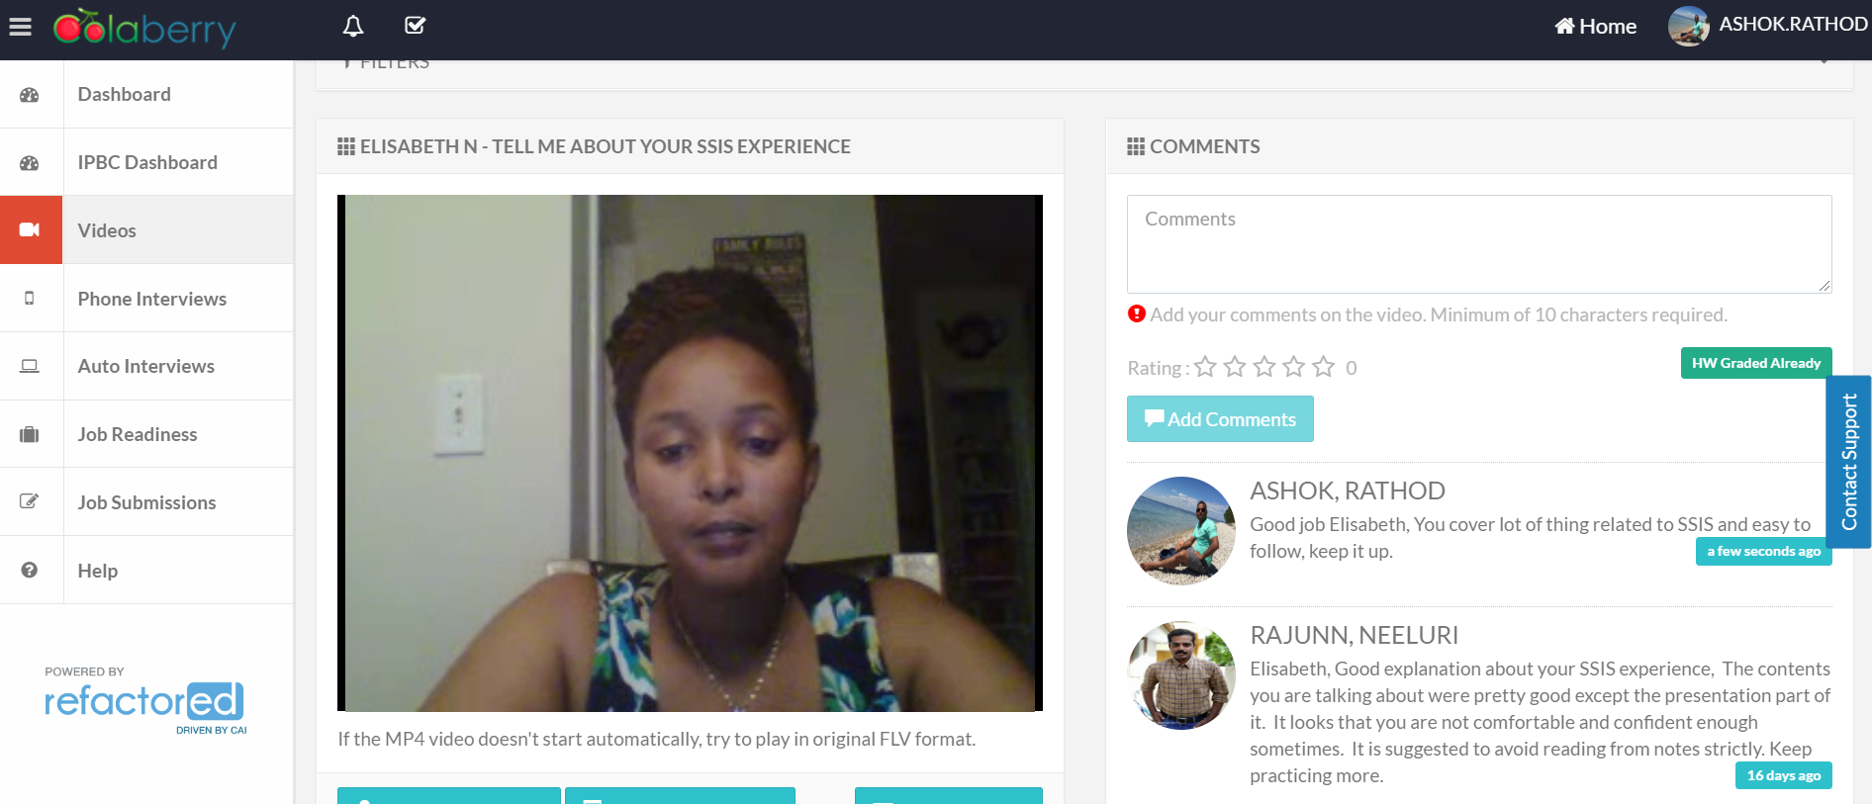

3. 30 Videos - Screenshot of Video Completion Dashboard showing 30+ Videos completed

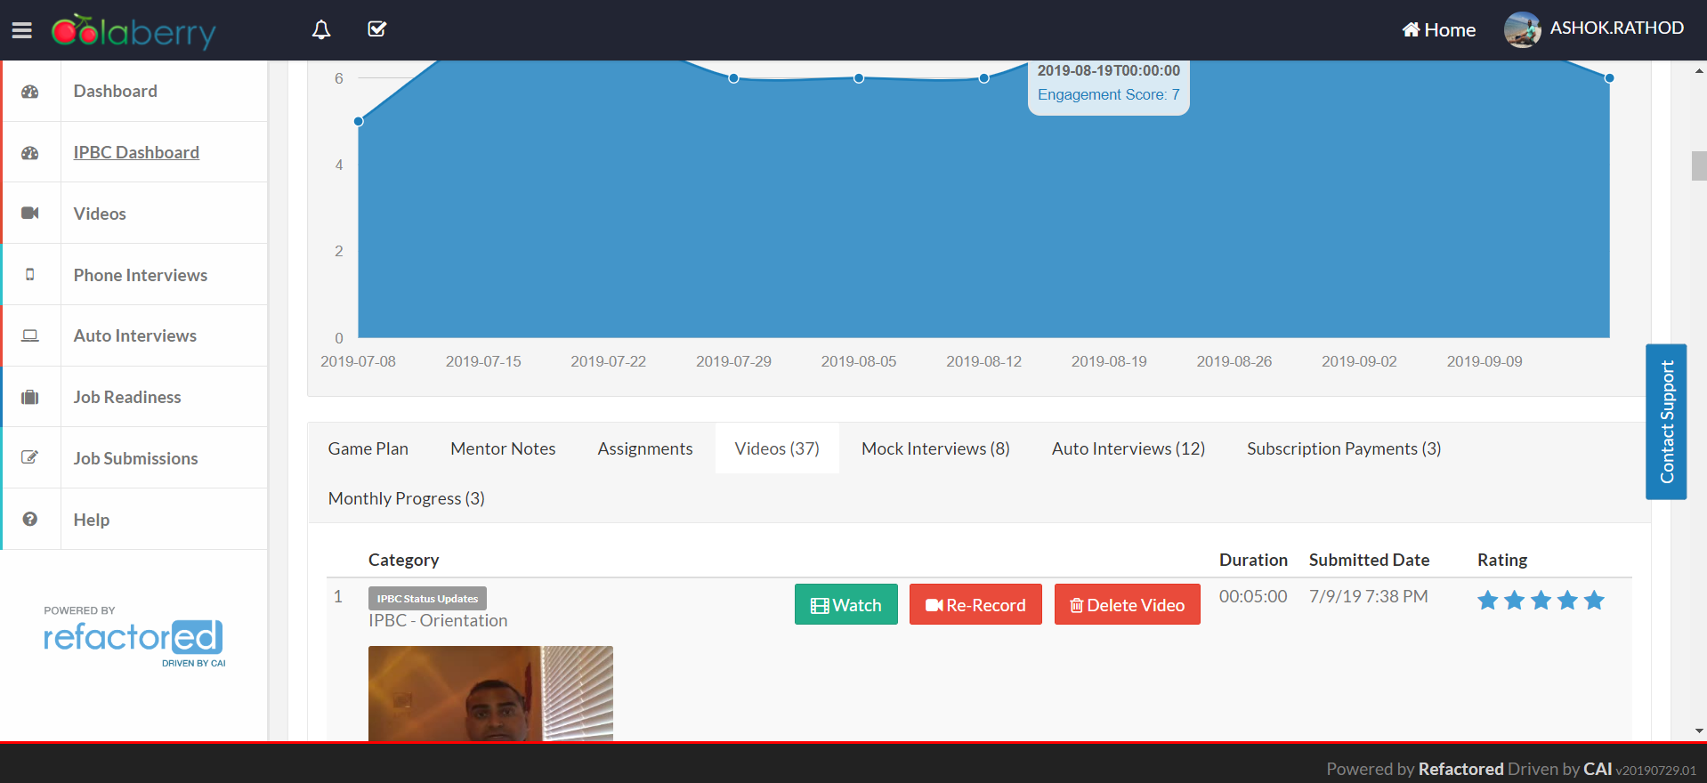

4. 12 Mock Interviews: Screenshot of Auto and Instructor Interview Dashboard showing 12+Interviews completed 